Bachkhoa – Aptech Center
Hanoi,Vietnam
--o0o--



Clinic Management
eProject name: Online Clinic Management

Batch : 1212L
Falculty:
Team: Group 2
Member: 1.Trinh Van Dong (C) B6067
2.Nguyen Duc Tam B6343
3.Nguyen Vu Hong Ky B6102
4.Bui Van Thanh B6392

Ha Noi 6/2014

Table of Content

I. Problem Definition 4
1. Acknowledgement: 4
2. Synopsis: 4
3. Problem Definition : 4
II. Customer Requirement Specification(CRS) 5
III. Architecture and Design of the Project 7
IV. Data Flow Diagram 8
V. Entity Relationship Diagram 9
10
VI. Database Design/ Structure 16
VII. Flow Chart of Application : 17
VIII. Interface…………………………………………………………………………………….21

Problem Definition

Acknowledgement:

I would like to acknowledge all those who have given me moral support and helped in making the project a success.
I wish to express my gratitude to the eProject Team at the Head Office, who guided and helped me. I would also like to express my gratitude to all the staff members of centre for not only providing me with the opportunity to work with them on this project, but also for their support and encouragement throughout the process.
I also express my sincere gratitude to the eProject Team at the Aptech Head Office and my project guide at the organization, for hi valuable guidance and support for the completion of this project.
And finally, i would like to offer many thanks to all my colleagues for their valuable suggestions and constructive feedback.

Synopsis:
From the beginning in the scientific laboratories and research establishments, computers have enclosed to become essential for modern business and industry. Today their presence is felt in all way of life such as making passenger reservation for the railways, forecasting the weather, monitors and run power plants, helping hospital to render service to patients etc.

Problem Definition :
Computers have very large storing capacity. Computers also do not make mistakes. Error in computing is generally due to negligence rather than logical faults. The vital characteristics such as each module are to play a center role in ourselves. Since the computer is an electronic data processing machine, it can perform innumerable number of operators in just a few seconds. This processing speed of a computer is usually measured in nanosecond. Computer can perform a wide range of jobs with speed, accuracy and diligence. The areas of application are many:-
- Scientific Application
- Medical Application
- Educational Application
- Business Application
The software is developed for providence clinic. This project deals with the task of computerizing the lab and pharmacy of the providence clinic. The software is developed in Visual Basic containing coding programs. It is a very fast high level language developed mainly for business purpose. Some new scientific machine and medicines must be stated in the Home Page. Home Page must be designed with an Introduction to the site and all the navigation links available. Upcoming activities must be flashed in the Home Page. The image must be added with its caption and alt attribute defined.

ADMIN: There should be admin Login separate where the entire data of the application can be updated. Admin must maintain the client details and online transaction details. Even keep the track of the all the education activities carried like seminar, practical’s. When the lecture is to be conducted and at what time must be stated in the education link.

Customer Requirement Specification(CRS)

- Business / Project Objective:

- Inputs provided by the Client:

  - List of inputs to the System:

+ Customers Information :
- UserName
- Password
- CustomerName
- Birthday
- Address
- Phone
- Mobile
- Email
- CreateDate
- Status

  - List of outputs from the System:

+ News
- Title
- Description
- Tag
- Image
- Detail
- Date
- Priority
- Index
- Active
- GroupNews
- Lang

+ Product
- Name
- Description
- Tag
- Image
- Detail
- Date
- Priority
- Index
- Active
- GroupNews
- Lang
- Price
- Content
- Priority
- Title
- Category
- Order
- PiceOld
- Keyword
- Code Product
- Count

  - Expected Delivery Dates:
    - 12/06/2010.

  - List of Deliverables:
    - Document.
    - Application.

- Hardware Requirements :

- A minimum computer system that will help you access all the tools in the courses is a Pentium 166 or better .
- 256 Megabytes of RAM or better.
- Windows 2000 (or higher if possible).

4. Software Requirements :

- Visual studio
- SQL Server

Architecture and Design of the Project

The application will be made of a Web-based distributed three-tier architecture to support multiple user transactions at the same time.

User interface – JSP Pages & HTML Pages

Business Logic – Java Beans

Database Access – SQL Server

Tier 2
Middle tier

Tier 3
Database tier

Tier 1
Presentation tier

Data Flow Diagram

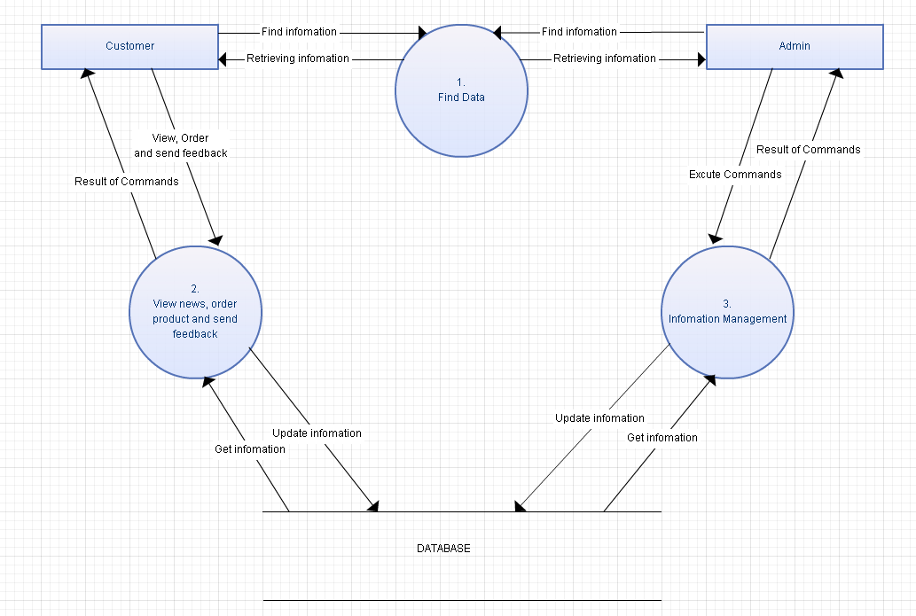

Entity Relationship Diagram

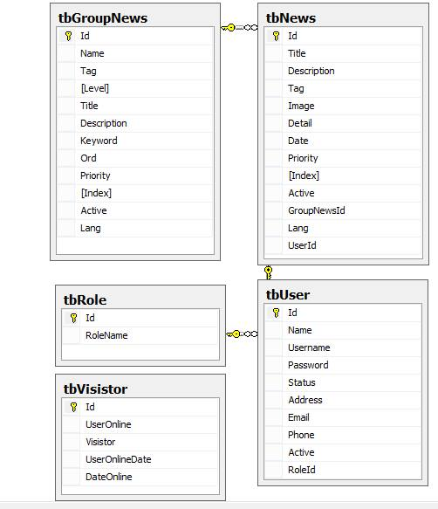

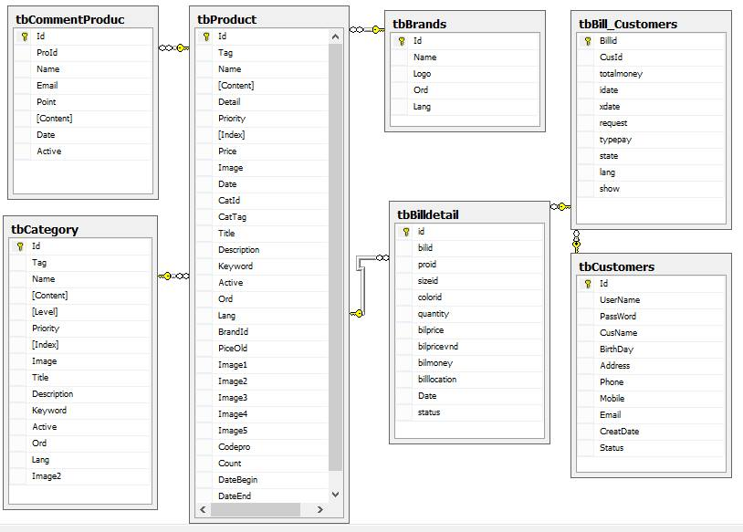

Database Design/ Structure

Table: tbVisistor
No. | Field Name | Data Type | Key | Description
1. | Id | int | PK | Stores the identification number of the visistor
2. | UserOnline | Int |  | User online
3. | Visistor | Bigint |  | Stores the visistor
4. | UserOnlineDate | Int |  | Stores the user name online
5. | DateOnline |  |  | Stores the date online

Table: tbBrands
No. | Field Name | Data Type | Key | Description
1. | id | int | PK | Stores the identification number of the Brands
2. | Name | nvarchar (400) |  | Stores the name of the Bands
3. | Logo | Varchar(300) |  | Stores the logo of brands
4. | Ord | Int |  | Stores the numerical order
5. | Lang | Varchar(5) |  | Stores the languages

Table: tbGroupNews
No. | Field Name | Data Type | Key | Description
1. | id | Int | PK | Stores the identification number of Group News
2. | Name | varchar (256) |  | Stores the name of Group News
3. | Tag | Nvarchar(256) |  | Stores the name of tag
4. | Level | Varchar(256) |  | Stores the level
5. | Title | Nvarchar(256) |  | Stores the title of news
6. | Descrition | Nvarchar(256) |  | Stores the description of Group News
7. | Keyword | Nvarchar(256) |  | Stores the keyword of Group News
8. | Ord | Int |  | Stores the numerical order
9. | Priority | Int |  | Stores the priority of group news
10. | Index | Int |  | Stores the index
11. | Active | Int |  | Stores the active
12. | Lang | Varchar(5) |  | Stores the languages

Table: tbProduct
No. | Field Name | Data Type | Key | Description
1. | id | Int | PK | Stores the identification number of the product
2. | Tag | Nvarchar(256) |  | Stores the tag
3. | Name | Nvarchar(256) |  | Stores the product name
4. | Content | nText |  | Stores the content
5. | Detail | Ntext |  | Stores the detail
6. | Priority | Smallint |  | Stores the priority
7. | Index | Smallint |  | Stores the index
8. | Price | Float |  | Stores the price
9. | Image | Varchar(150) |  | Stores the image
10. | Date | Datetime |  | Stores the date
11. | CatId | Int | FK | Stores the identification number of the category
12. | CatTag | Nvarchar(256) |  | Stores the category tag
13. | Title | Nvarchar(300) |  | Stores the title
14. | Description | Nvarchar(300) |  | Stores the description in product
15. | Keyword | Nvarchar(300) |  | Stores the keyword
16. | Active | Int |  | Stores the active
17. | Ord | Int |  | Stores the numerical order
18. | Lang | Varchar(5) |  | Stores the languages
19. | BrandId | Int | FK | Stores the identification number of the brand
20. | PriceOld | Varchar(200) |  | Stores the price
21. | CodePro | Varchar(200) |  | Stores the Code
22. | Count | Int |  | Stores the Count
23. | DataBegin | Datetime |  | Stores the data begin.
24. | DataEnd | datetime |  | Stores the data end.

Table: tbNews
No. | Field Name | Data Type | Key | Description
1. | Id | Int | PK | Stores the identification number of the new
2. | Title | Nvarchar(256) |  | Stores the title
3. | Description | Vvarchar(256) |  | Stores the description in new
4. | Tag | Nvarchar(256) |  | Stores the tag
5. | Image | Varchar(256) |  | Stores the image.
6. | Detail | Ntext |  | Stores the detail
7. | Date | Datetime |  | Stores the new date
8. | Priority | Int |  | Stores the priority
9. | Index | Int |  | Stores the index
10. | Active | Int |  | Stores the active
11. | GroupNewsId | Int | Fk | Stores the identification number of the Group
N | Lang | Varchar(5) |  | Stores the languages
13. | UserId | Int | FK | Stores the identification number of the user

Table: tbCustomers
No. | Field Name | Data Type | Key | Description
1. | id | int | PK | Stores the identification number of the Customer
2. | UserName | Nvarchar(100) |  | Stores the user name
3. | Password | Nvarchar(200) |  | Stores the password
4. | CusName | Nvarchar(200) |  | Stores the customer name
5. | BirthDay | Nvarchar(100) |  | Stores the birth day of the Customer
6. | Address | Nvarchar(200) |  | Stores the Customer address
7. | Phone | Varchar(200) |  | Stores the phone of the customer
8. | Mobile | Varchar(100) |  | Stores the customer mobile
9. | Email | Varchar(100) |  | Stores the content of the day
10. | CreateDate | Datetime |  | Stores the create date
11. | Status | Bigint |  | Stores the status

Table: tbCategory
No. | Field Name | Data Type | Key | Description
1. | id | Int | PK | Stores the identification number of the Category
2. | Tag | Nvarchar(256) |  | Stores the Tag
3. | Name | Nvarchar(256) |  | Stores the name of the Category
4. | Content | Ntext |  | Stores the Content
5. | Level | Nvarchar(100) |  | Stores the Level
6. | Priority | Smallint |  | Stores the Priority of the Category
7. | Index | Smallint |  | Stores the Index
8. | Image | Varchar(256) |  | Stores the Image of the Category
9. | Title | Nvarchar(300) |  | Stores the Title
10. | Description | Nvarchar(300) |  | Stores the description in Category
11. | Keyword | Nvarchar(300) |  | Stores the Keyword of the Category
12. | Active | Int |  | Stores the Active
13. | Ord | Int |  | Stores the numerical order
14. | Lang | Varchar(5) |  | Stores the languages

Table: tbRole
No. | Field Name | Data Type | Key | Description
1. | Id | int | PK | Stores the identification number of the Role
2. | Roldname | Int |  | Stores the role name

Table: tbBill_Customers
No. | Field Name | Data Type | Key | Description
1. | Id | Int | PK | Stores the identification number the Bill
2. | UserName | Nvarchar(100) |  | Stores the user Name
3. | Password | Nvarchar(200) |  | Stores the password
4. | CusName | Nvarchar(200) |  | Store the customers
5. | Birthday | Nvarchar(100) |  | Stores the birth day of the bill
6. | Address | Nvarchar(200) |  | Stores the address of the Bill
7. | Phone | Varchar(100) |  | Stores the phone of the Bill
8. | Mobile | Varchar(100) |  | Stores the Mobile
9. | Email | Varchar(100) |  | Stores the e-mail of the Bill
10. | CreatDate | Datetime |  | Stores the date time of the Bill
11. | Status | bigint |  | Stores the Status

Table: tbUser
No. | Field Name | Data Type | Key | Description
1. | Id | int | PK | Stores the identification the number the User
2. | Name | Nvarchar(256) |  | Stores the name of the User Name
3. | Username | Varchar(64) |  | Stores the User Name
4. | Password | Varchar(64) |  | Stores the password
5. | Status | Bit |  | Stores the Status
6. | Address | Nvarchar(50) |  | Stores the user address
7. | Email | Nvarchar(50) |  | Stores the e-mail of the user
8. | Phone | Nvarchar(20) |  | Stores the phone of the user
9. | RoleId | Int | Fk | Stores the identification number of the role

Flow Chart of Application :

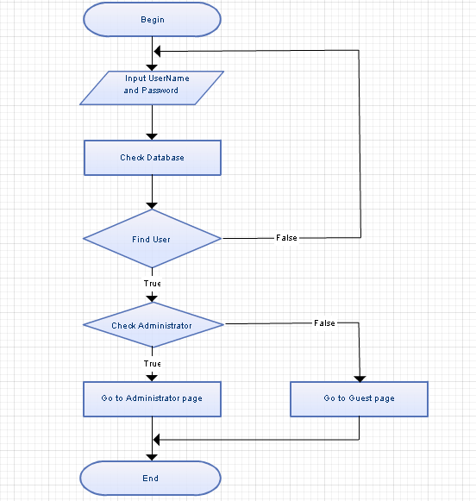

Login Flow Chart

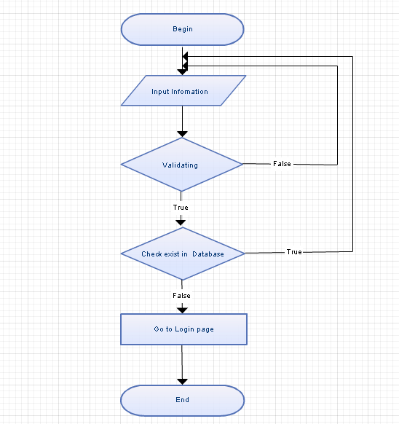

Register Flow Chart

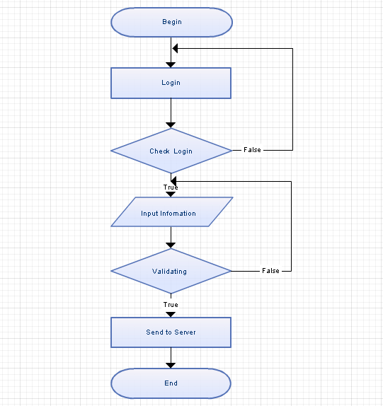

Feedback from customer Flow Chart

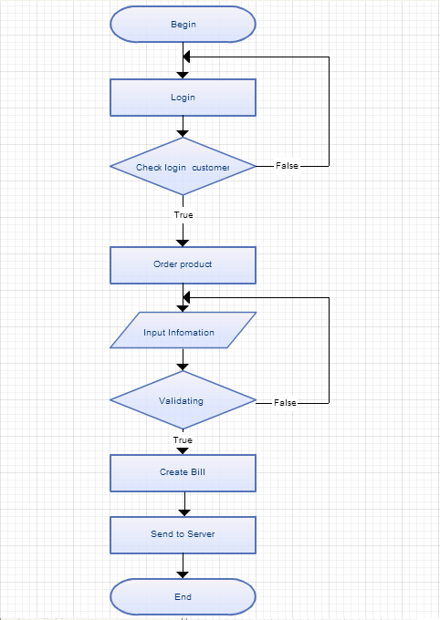

Order Product Flow Chart

INTERFACE

